Devansh Gupta

01609278

**CIS 455 – Homework #5**

**Problem 5-1.**

Consider the Exon Chaining problem in the case when *all intervals have the same weight*.

1. (15 points) Design a greedy algorithm that finds an optimal solution for this limited case of the problem, and

describe your algorithm in pseudocode format.

2. (5 points) Show how your algorithm would solve the example in Figure 6.26 (page 202) if all 9 intervals had the

same weight.

Solution:

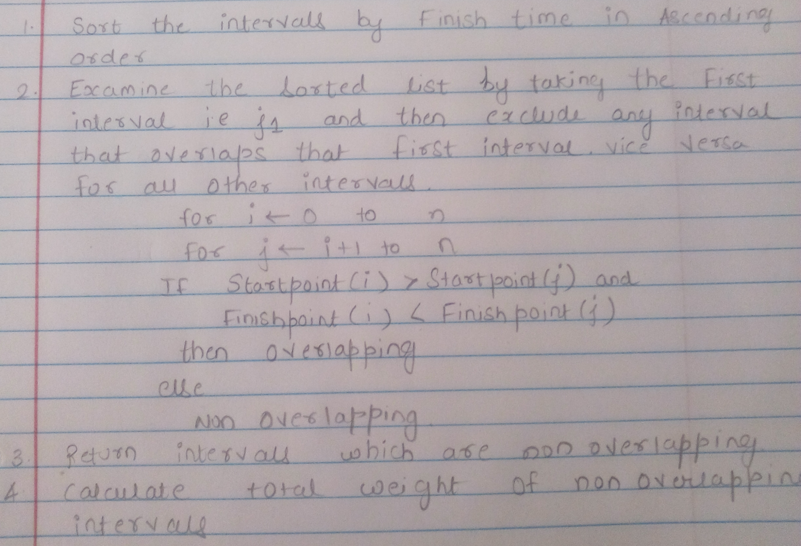

Code:

#include<stdio.h>

#include<stdlib.h>

int main()

{

int temp=0;

int interval=0;

int temp1=0;

int count;

int nos=0;

int a[10][2];

int b[10][2];

int i=0,j=0;

printf("\n Please enter the number of sets:");

scanf("%d",&count);

printf("\nPlease enter sets:");

for(i=0;i<count;i++)

scanf("%d %d",&a[i][1],&a[i][2]);

printf("\nPlease enter the common weight of intervals:");

scanf("%d",&interval);

temp1=0;

printf("\nSets are as follows:");

for(i=0;i<count;i++)

{

printf("%d %d",a[i][1],a[i][2]);

printf("\n");

}

printf("\nSorting on basis of end points");

temp=a[1][1];

for(i=0;i<count;i++)

for(j=i+1;j<count;j++)

if(a[i][2]>a[j][2])

{

temp=a[j][2];

a[j][2]=a[i][2];

a[i][2]=temp;

temp=a[j][1];

a[j][1]=a[i][1];

a[i][1]=temp;

}

for(i=0;i<count;i++)

for(j=i+1;j<count;j++)

if(a[i][1]>a[j][1]&&a[i][2]<a[j][2])

{

a[j][2]=0;

a[j][1]=0;}

printf("\n Sorted set:");

for(i=0;i<count;i++)

if(a[i][1]!=0&&a[i][2]!=0){

printf("%d %d\n",a[i][1],a[i][2]);

temp1++;

}

printf("\n Total Interval is %d",interval*temp1);

getchar();

}

Output:

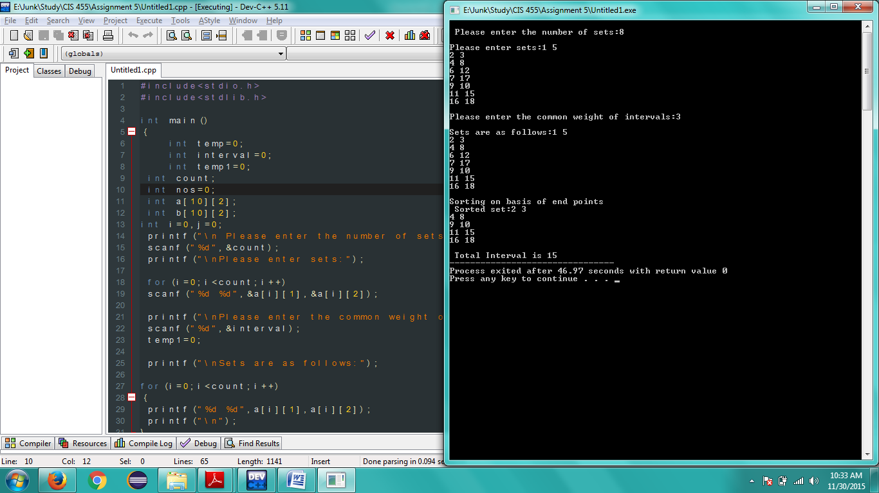

**Problem 5-2.** (10 points) Jones & Pevzner, Problem 7.1, page 244.

Construct the recursion tree for MergeSort on the input (2, 5, 7, 4, 3, 6, 1, 8).

Solution:

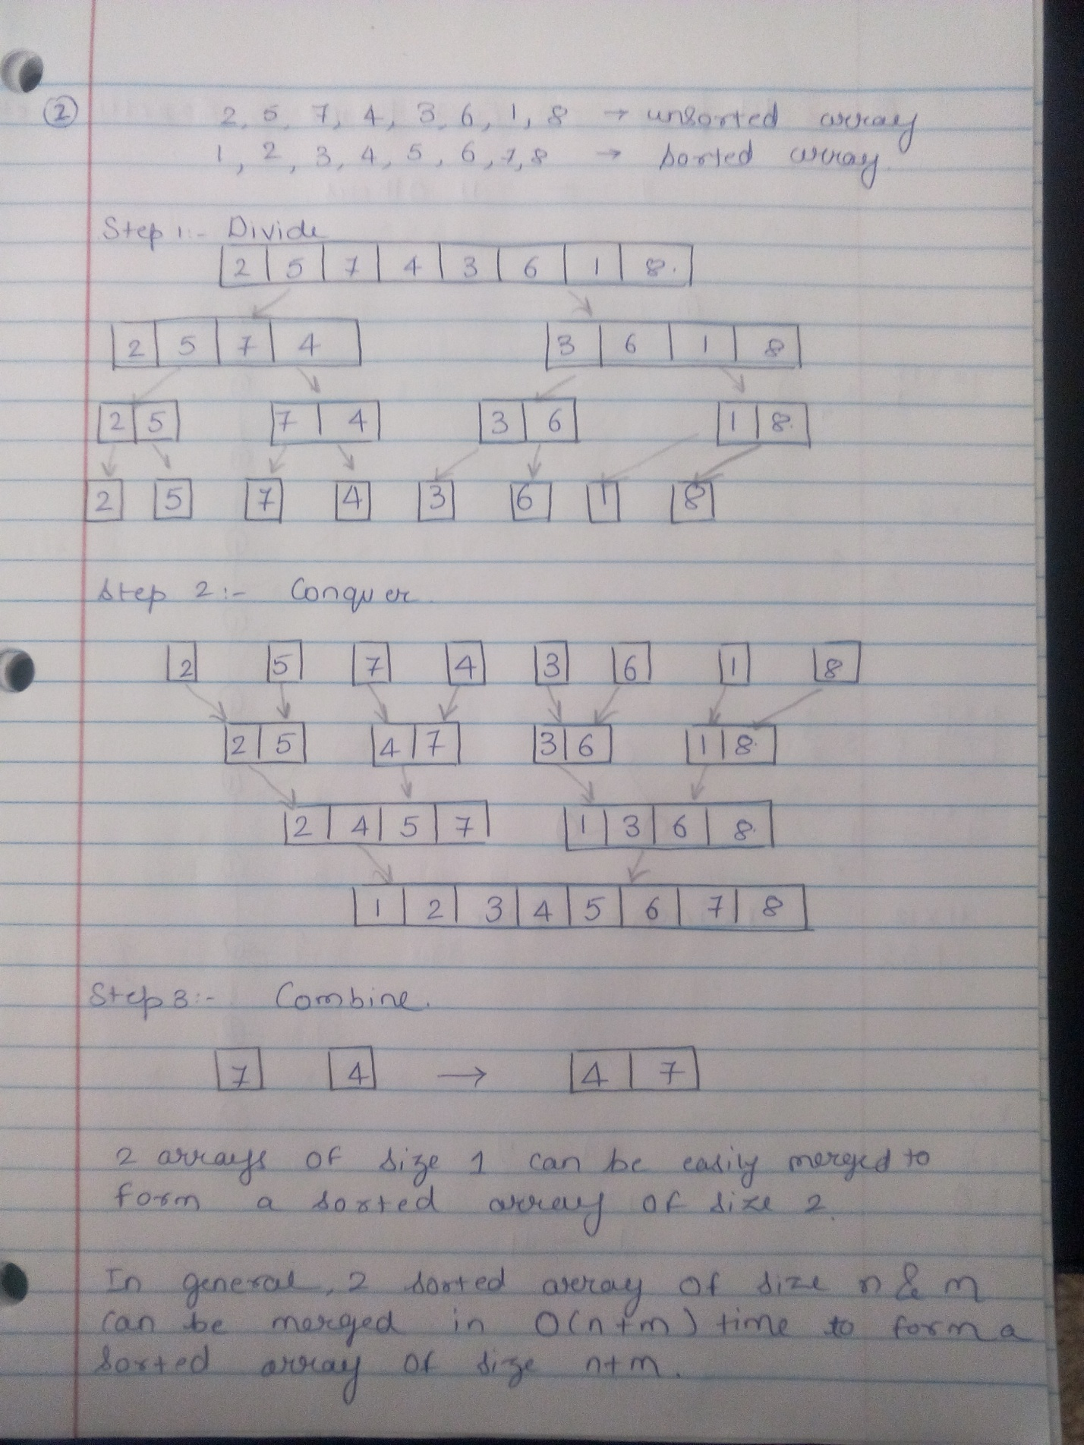

**Problem 5-3.** (10 points) Jones & Pevzner, Problem 8.1, page 302.

Can 99 phones be connected by wires in such a way that each phone is connected with exactly 11 others? (2 points)

Why/why not? (8 points)

Solution:

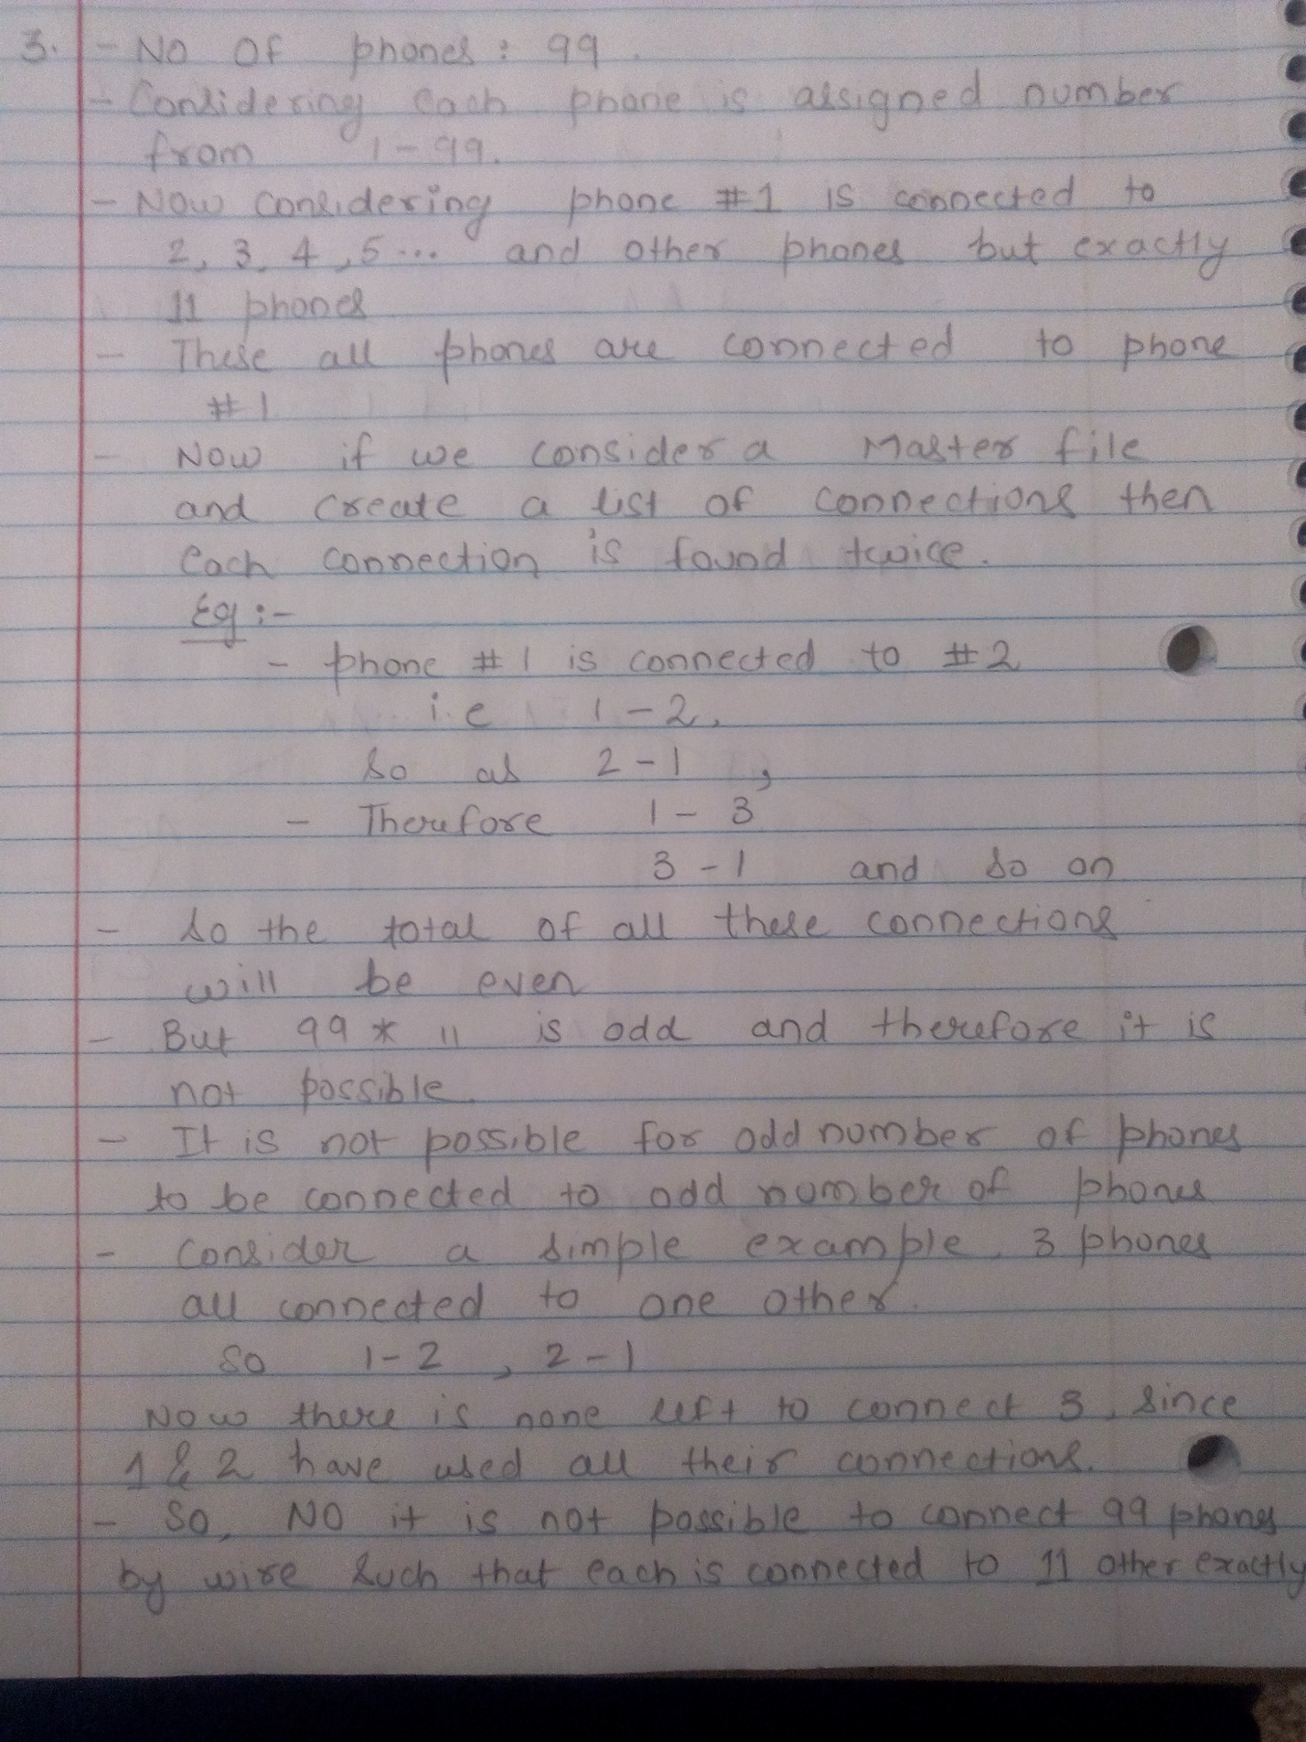

**Problem 5-4.** (10 points) Jones & Pevzner, Problem 8.5, page 302.

Can one use a 12-inch-long wire to form a cube? (each of the 12 cube edges is 1-inch long) (5 points)

If not, what is the smallest number of cuts one must make to form this cube? (5 points)

Solution: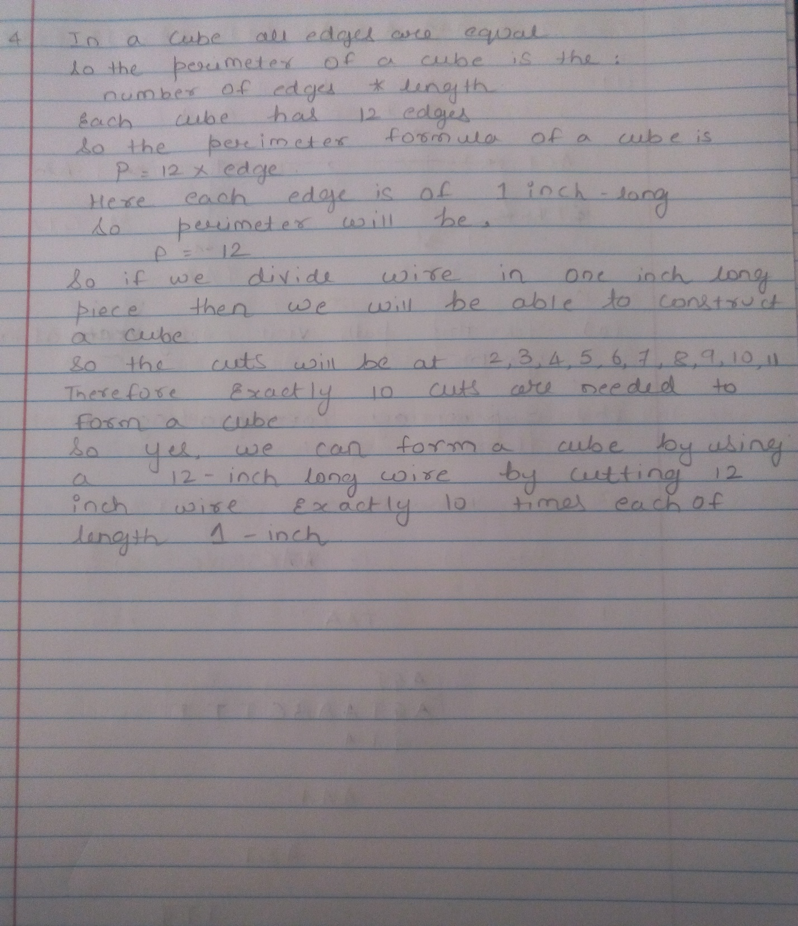

**Problem 5-5.** (30 points) Jones & Pevzner, Problem 8.6, page 302.

Find the shortest common superstring for eight 3-mers: {AGT, AAA, ACT, AAC, CTT, GTA, TTT, TAA} and solve the

following two problems:

1. Construct the graph with 8 vertices corresponding to these 3-mers (Hamiltonian path approach) and find a

Hamiltonian path (7 edges) which visits each vertex exactly once. (10 points)

a. Does this path visit every edge of the graph? (2 points)

b. Write the superstring corresponding to this Hamiltonian path. (3 points)

2. Construct the graph with 8 edges corresponding to these 3-mers (Eulerian path approach) and find an Eulerian path

(8 edges) which visits each edge exactly once. (10 points)

a. Does this path visit every vertex of the graph exactly once? (2 points)

b. Write the superstring corresponding to this Eulerian path. (3 points)

Solution:

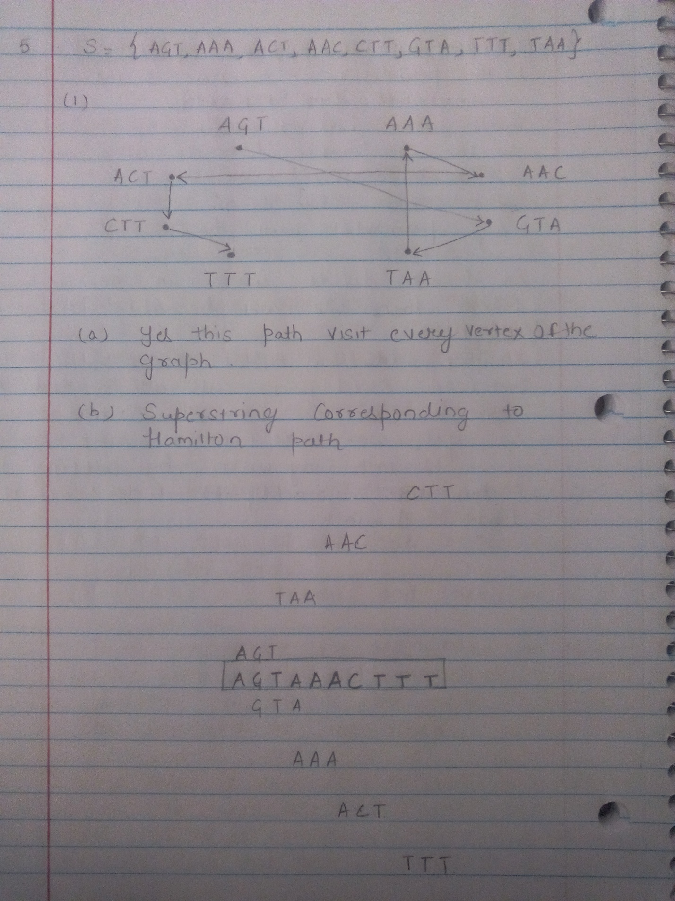

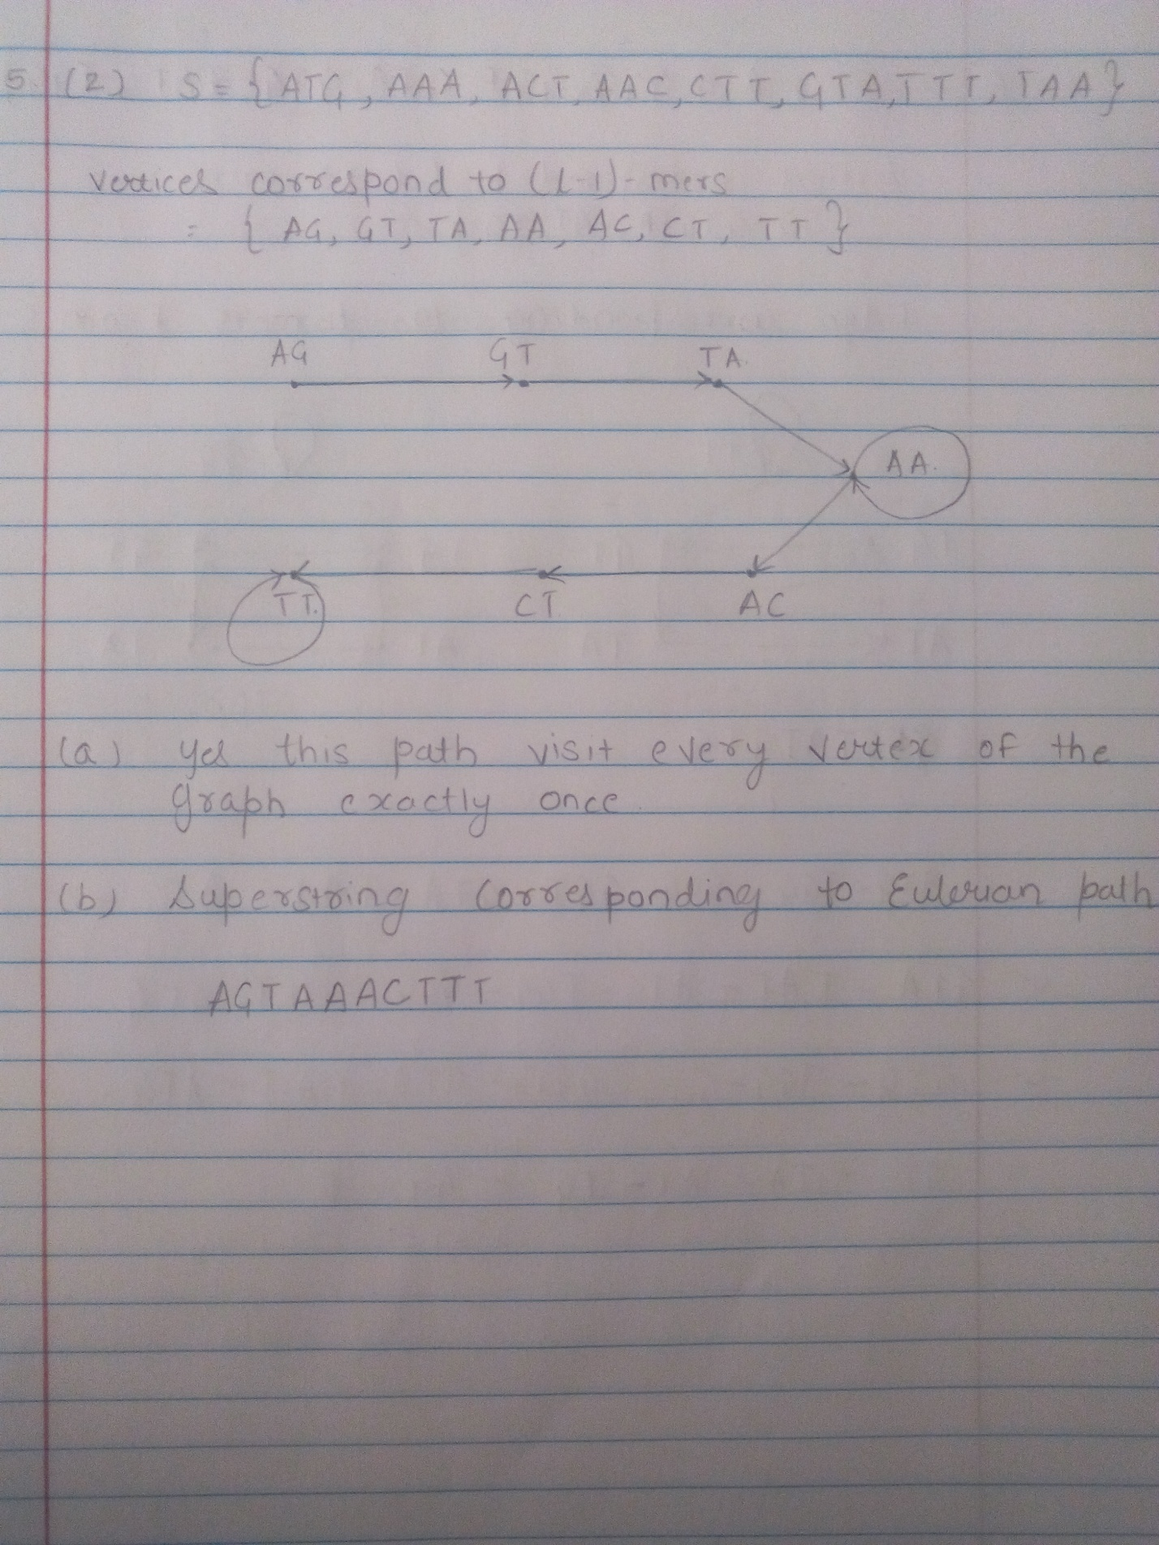

**Problem 5-6.** (20 points) Jones & Pevzner, Problem 8.9, page 303.

Use the Eulerian path approach to solve the SBH problem for the following spectrum:

***S*** = {ATG, GGG, GGT, GTA, GTG, TAT, TGG}

Label edges and vertices of the graph, and **give *all* possible sequences** *s* such that *Spectrum*(*s*,3) = ***S***.

Solution:

